**EXP NO: 1**

**DATE:09/02/2023**

**CREATE A SIMPLE CLOUD SOFTWARE APPLICATION AND PROVIDE IT AS A SERVICE USING ANY CLOUD SERVICE PROVIDER TO DEMONSTRATE SOFTWARE AS A SERVICE (SAAS).**

**AIM:**

To create a simple cloud software application and provide it as a service using it as a service using any cloud service provider to demonstrate Software as a Service (SAAS).

**PROCEDURE:**

STEP1: GOTO ZOHO.COM

STEP 2: LOGIN TO THE ZOHO.COM

STEP 3: SELECT ONE APPLICATION

STEP 4: ENTER APPLICATION NAME

STEP 5: CREATE A NEW APPLICATION

STEP 6: SELECT ONE FORM

STEP 7: THE SOFTWARE HASE BEEN CREATED.

**IMPLEMENTATION:**

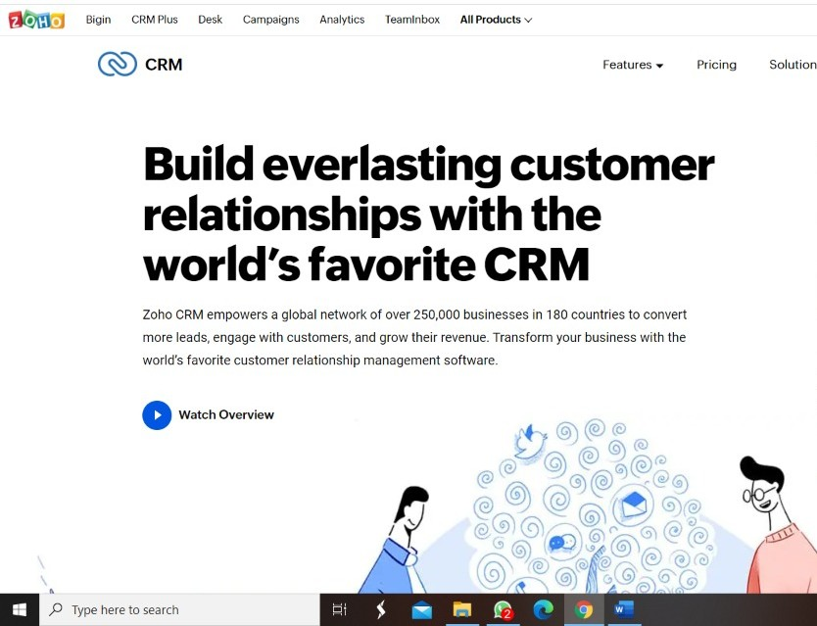**STEP1: GOTO ZOHO.COM**

**STEP 2: LOGIN TO THE ZOHO.COM**



**STEP 3: SELECT ONE APPLICATION**

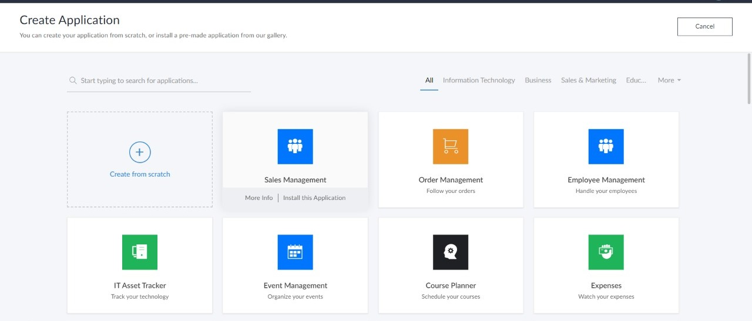

**STEP 4: ENTER APPLICATION NAME**

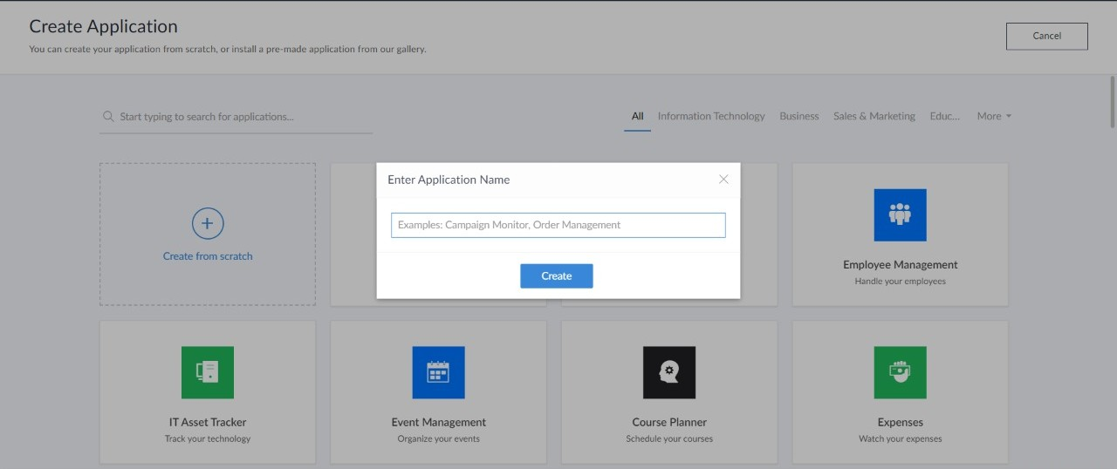

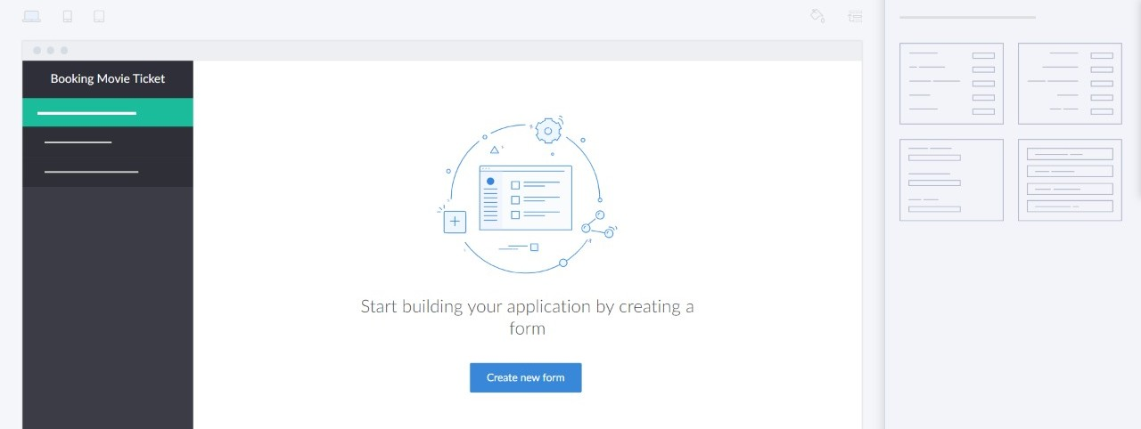**STEP 5: CREATED NEW APPLICATION**

**STEP 6: SELECT ONE FORM**

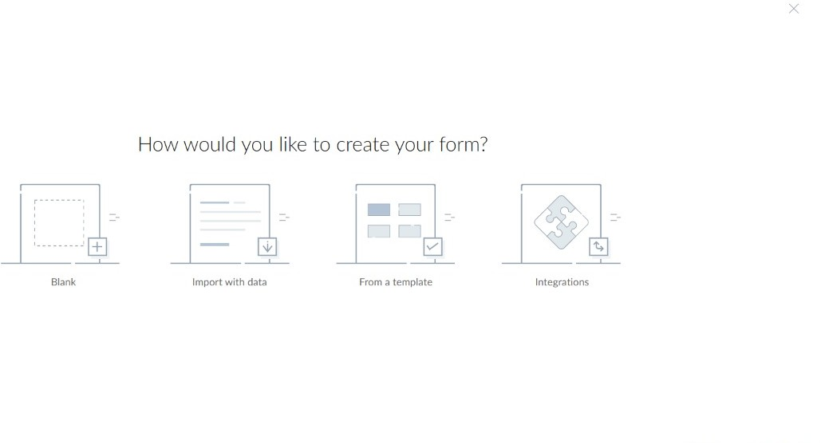

**STEP 7: THE SOFTWARE HASE BEEN CREATED.**

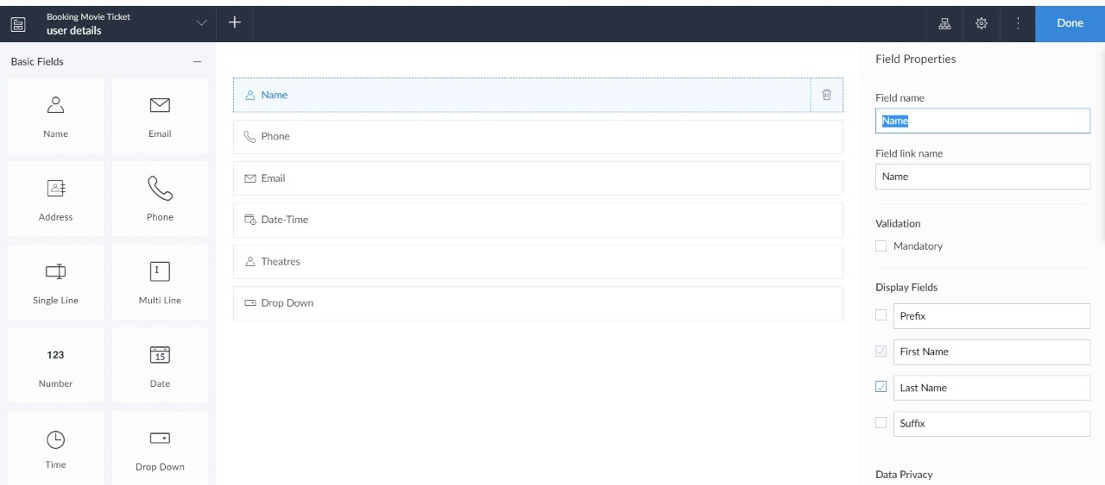

**OUTPUT:**

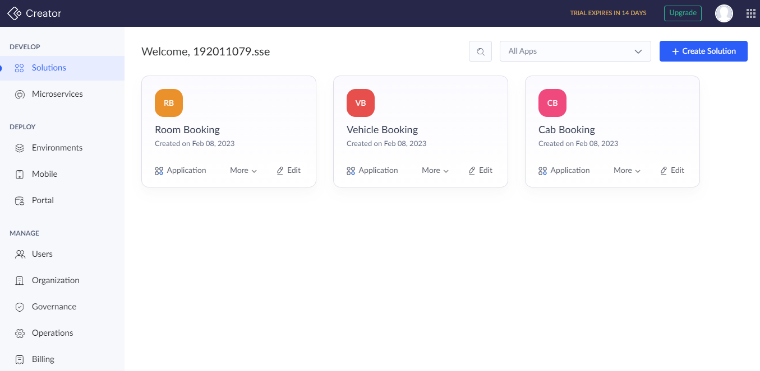

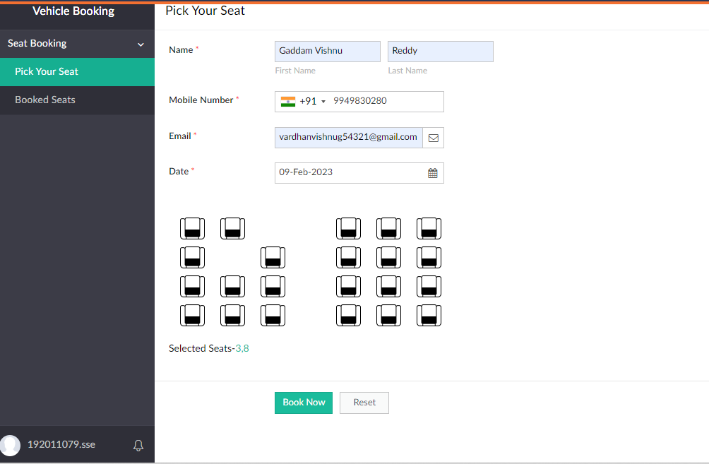

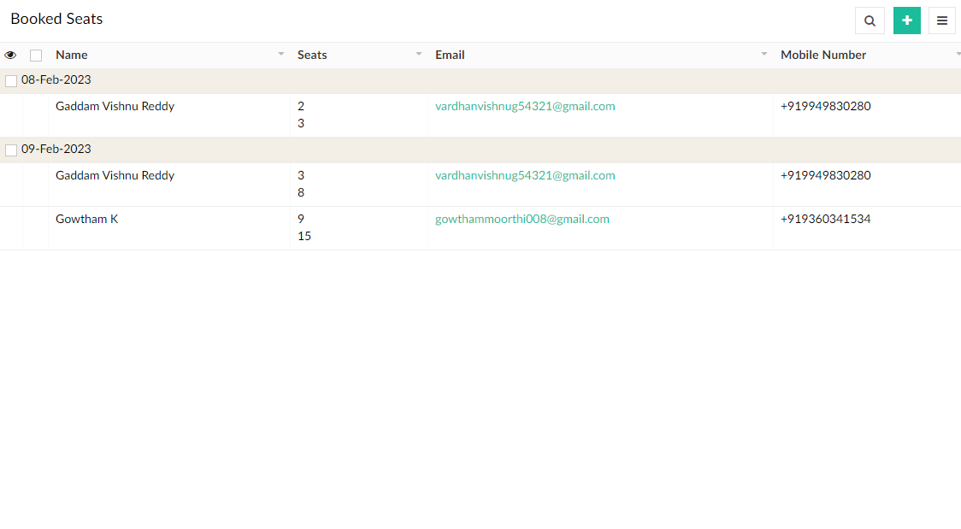

**RESULT:**

Hence the creation of a simple cloud software application and provide it as a service using it as a service using any cloud service provider to demonstrate Software as a Service (SAAS) is performed successfully